34.33: 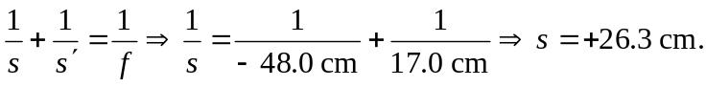
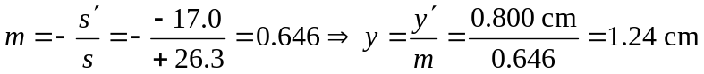tall, erect, same side.

